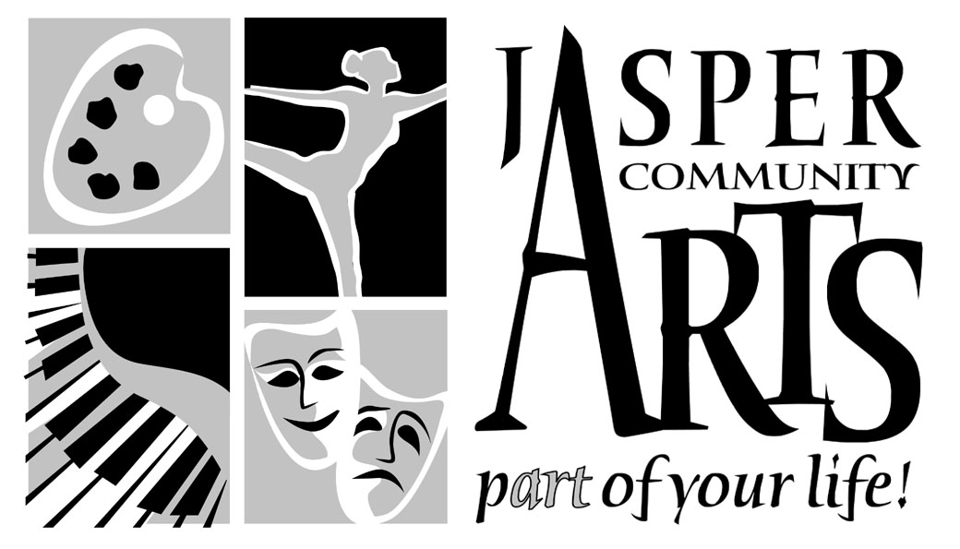

Jasper Community Arts

951 College Avenue

Phone: 812-482-3070

Fax: 812-634-6997

[www.jasperarts.org](http://www.jasperarts.org)

E-mail: kmiracle@jasperindiana.gov

# MEDIA RELEASE

**FOR IMMEDIATE RELEASE**

**DATE: March 1, 2017**

**CONTACT PERSON: KIT MIRACLE, DIRECTOR**

**SUBJECT: ROB TORRES TO PERFORM FAMILY SHOW AT JASPER ARTS CENTER**

International comedian Rob Torres will round out this season’s Family Fun Series at Jasper Arts Center on Saturday, March 11, 2017 at 3:30 p.m. presented by Jasper Community Arts. Audiences of all ages will take pleasure in the lively antics of this performer.

Whether he's changing his clothes, setting the table, or just sitting down, Rob Torres has a unique way of finding absurdity in everyday tasks. His award winning international comedy has made Rob Torres one of the foremost visual comedians in the world today. See for yourself why Rob Torres has been in great demand by top venues worldwide for the past decade, and why he is renown around the globe as the *International Man of Mirth!*

In 1992 Rob Torres began traveling the world with the Clyde Beatty Cole Bros Circus. In his first season he toured 121 cities in the USA and performed in over 550 shows. That was just the beginning. Years later after performing his way through a few different continents, Rob returned to the USA to perform in, and later create 7 different specialty shows for Walt Disney World resorts in Orlando, Florida USA. Rob’s travels then led him to Tokyo, Japan where he stayed for 2 years. His success there with a television show and other theatrical contracts led Rob to Europe where his success has won him many comedy and circus awards at international performing arts and circus festivals.

From the moment he walks on stage or into the ring, Rob steps into the hearts of his audience and keeps them laughing long after he's gone. For the past two decades Rob Torres has traveled to over 45 countries performing in theatres, circuses, varieties, galas, TV and film. Rob has masterfully blended his formal training in theatre, circus arts, and pantomime together to create genuinely fun and memorable performances.

This performance is suitable for all ages. There will only be one performance on Saturday, March 11th at 3:30 p.m. Order your tickets now by calling the Jasper Arts Center right away at (812) 482-3070. Prices are $15 for adults and seniors and $8 for students and children.

Jasper Community Arts is a department of the City of Jasper. Additional support is provided by Friends of the Arts, Inc. and the Vanderburgh County Community Foundation.

#####