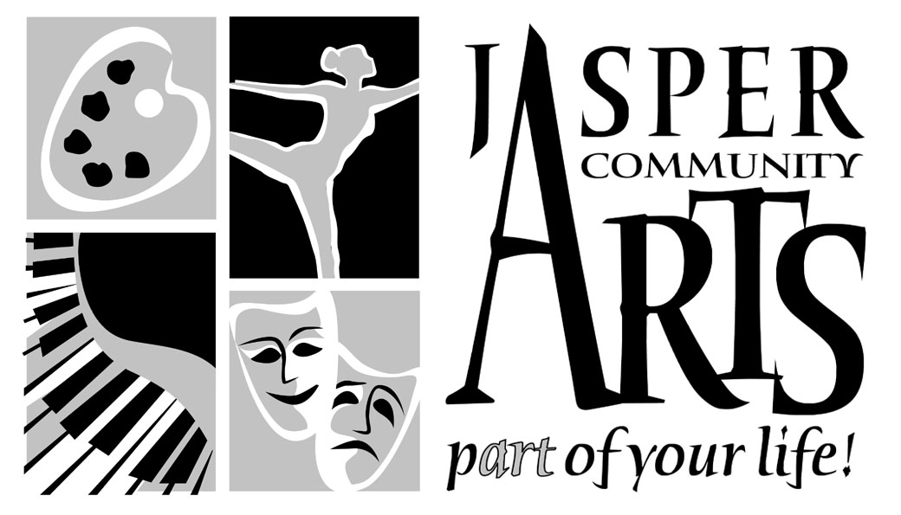

Jasper Community Arts

951 College Avenue

Phone: 812-482-3070

Fax: 812-634-6997

[www.jasperarts.org](http://www.jasperarts.org)

E-mail: kmiracle@jasperindiana.gov

# MEDIA RELEASE

**FOR IMMEDIATE RELEASE**

**DATE: February 8, 2017**

**CONTACT PERSON: KIT MIRACLE, DIRECTOR**

**SUBJECT: BLACK VIOLIN AT JASPER ARTS CENTER**

The amazing duo Black Violin will perform at the Jasper Arts Center on Saturday, February 19, 2017 at 7:30 p.m.

**Black Violin** is composed of classically trained violist and violinist **Wil B. (Wilner Baptiste)** and **Kev Marcus (Kevin Sylvester)**who combine their classical training and hip-hop influences to create a distinctive multi-genre sound that is often described as “classical boom.” This Florida duo met in high school, went to different colleges, and then later reconvened to create the musical group Black Violin. The duo plays a variety of music (relying heavily upon classical music), but are often categorized as hip hop because of the changes to the rhythm and beats. This mingling of hip hop and classical sensibilities gives them their distinctive style.

The band released their major label debut *Stereotypes (*featuring Black Thought of The Roots and MC Pharoahe Monch) on Universal Music which debuted at #1 on the Billboard Classical Crossover Chart and #4 on the Billboard R&B Chart. **Black Violin** has shared stages with top names including Kayne West, Aerosmith and Tom Petty, and has creatively collaborated with the likes of Wu-Tang Clan, Wyclef Jean and Alicia Keys. The band is currently touring the US and Europe, as well as composing the score for Fox’s new series, ***Pitch,*** which premiered Fall of 2016.

Despite their successful collaborations, Baptiste and Sylvester had disparate upbringings. As children, they were introduced to their instruments against their choice. Kev’s mother enrolled him in violin classes when he started getting into some minor trouble in the fifth grade. Wil B was actually interested in taking saxophone lessons but ended up in the wrong class and stuck with viola. They both had teachers who inspired them to continue with their musical careers. This has carried through to their mission to bring music to children throughout the world. They have performed an average of about 200 shows a year in 49 states and 39 countries, while appearing at official NFL celebrations for three Super Bowls and last year’s U.S. Open in Forest Hills with Jordin Sparks. They have played their music for troops in Iraq, Presidential Inaugural Balls, and individually or together, with the talents of P. Diddy, Kanye West, 50 Cent, Tom Petty, Aerosmith, Aretha Franklin and The Eagles.

**Wil** and **Kev** place heavy emphasis on educational outreach, and have performed for more than 100,000 students in North America and Europe in the past 12 months, including the featured musical act for the Blue Ribbon Festival at the Music Center in Los Angeles, CA where they performed for 19,000 fifth grade students from the Greater Los Angeles area over a 3 day period. The band is endorsed by **Yamaha Music**, and has partnered with the **National Association for Music Manufacturers** (NAMM) to continue their advocacy for accessible music education.

“Through the message of Black Violin’s music, we’ve spent the last 10 years working to encourage and empower people of all ages, ethnic and socioeconomic backgrounds to find what connects us, rather than shine a light on what divides us. This past year alone, we’ve played for nearly 100,000 students and over 125 public shows across the US and Europe. We’ve taken this opportunity to spread a message that challenges the world’s view of what it means to rise above labels, be daring enough to follow their passion and most of all, be true to themselves. As black men living in America, we understand challenges and we also understand the power of “I can’t”, yet we decide to live by and promote the power of “I can”. We realize that every opportunity to connect our diverse fans is an opportunity to break down the barriers that separate us, empower individually and encourage progress. Our UNITY tour, with concert dates through the US was our most energetic and inspired show yet.

Tickets are still available by calling the Jasper Arts Center at 812-482-3070. They are $35 for adults, $33 for seniors, and $30 for students and children. Don’t miss this opportunity to see one of the greatest duos in fusion music today.

Jasper Community Arts is a department of the City of Jasper. Additional support is provided by Friends of the Arts, Inc., the Indiana Arts Commission, and the National Endowment for the Arts. It is also a Kennedy Center Partner in Education and provides arts education programming to local schools.

#####