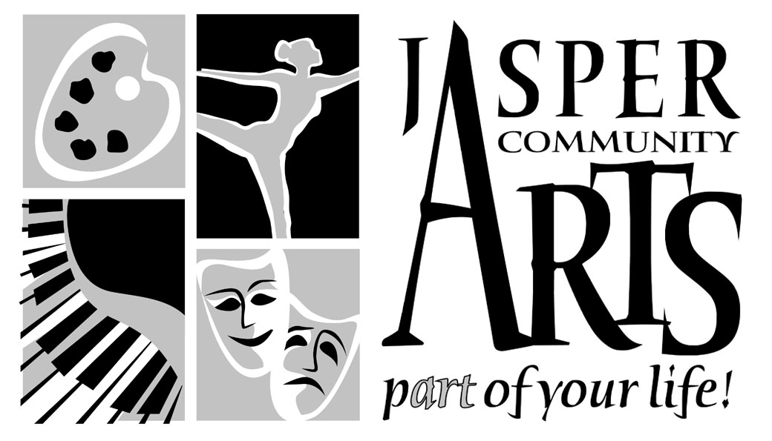

Jasper Community Arts

951 College Avenue

Phone: 812-482-3070

Fax: 812-634-6997

[www.jasperarts.org](http://www.jasperarts.org)

E-mail: kmiracle@jasperindiana.gov

# MEDIA RELEASE

**FOR IMMEDIATE RELEASE**

**DATE: March 9, 2017**

**CONTACT PERSON: KIT MIRACLE, DIRECTOR**

**SUBJECT: ALLAN HARRIS AND FRIENDS PLAY BACKSTAGE AT JASPER ARTS CENTER**

Allan Harris and friends will perform Friday, March 17, 2017 at 7:30 p.m. at the Jasper Arts Center. This is the final show in the Backstage series for the season.

The outstanding and internationally renowned vocalist, guitarist and composer Allan Harris sums up his personal perspective on music in clear and straightforward terms. "There is nothing that I have found that defines and gives credence to my place in this wild and mysterious universe than this thing called music." Harris exemplifies that statement perfectly with his stunning new album Nobody's Gonna Love You Better (Black Bar Jukebox Redux), his eleventh album following on the heels of his highly acclaimed 2015 release Black Bar Jukebox.

For this, Harris takes an even more eclectic approach, drawing upon the wide range of music that he heard growing up in Brooklyn, and feasting on the expansive palette of the Harlem cultural landscape. "My new album captures some of the varied sounds and feelings that have shaped my growth as an artist. I had not one style to heavily rely upon when putting these tunes together, but only my young memories of music, people and events."

Ever since he burst on the jazz scene in the latter part of the twentieth century, the Brooklyn-born, Harlem-based Allan Harris has reigned supreme as one of the most accomplished and exceptional singers of his generation. The Miami Herald aptly described Harris as an artist blessed with, “the warmth of Tony Bennett, the bite and rhythmic sense of Sinatra, and the sly elegance of Nat ‘King’ Cole.”

Harris’ soulful sound comes from his rich musical home life, which extended deep into the artistic world of Harlem. His mother, Johanna Chemina Ingram-Harris, was a concert pianist and was a graduate of the first class of New York’s legendary High School for the Performing Arts. Growing up, Harris went to the Apollo Sunday afternoon matinees, and he visited his aunt Kate’s famous soul food restaurant, Kate’s Home Cooking, located behind the Apollo Theater.

In this setting, Harris met many jazz and R&B stars who worked at the Apollo and came by the restaurant to eat and hang out. Through his aunt Phoebe, Harris met and was mentored by a seminal jazz figure, Clarence Williams. “We used to go to his record store, and he’d come into our house on Lincoln Avenue,” explains Harris. It was Williams who brought Louis Armstrong to the Harris home, and babysat the future crooner, who was frightened by Satchmo’s gravelly, “frog like voice.”

Over the past 20 years, Harris has steadily developed his reputation as one of the finest vocalists of his era. Brooklyn-born and Harlem-based, he has forged his sterling credentials through his ten previous albums, covering a broad range of contexts, all netted together within the rich territory of the jazz tradition. In addition to his recordings, he has performed on a worldwide stage that has taken him to prestigious international festivals and halls in Europe, the Middle East and Asia, as well as the 2012 Olympics in London. At home, he has toured nationally at festivals and top venues, including New York's Lincoln Center and D.C.'s Kennedy Center. He has received numerous awards, including the New York Nightlife Award for "Outstanding Jazz Vocalist" (which he won three times), the Backstage Bistro Award for "Ongoing Achievement in Jazz," the Harlem Speaks "Jazz Museum of Harlem Award," and the DownBeat Critic's Poll Award for "Rising Star Vocalist." Nobody's Gonna Love You Better (Black Bar Jukebox Redux) will continue to build his legacy as another milestone in the extraordinary artistic aesthetic of Allan Harris.

Patrons wishing to learn more about this musician can check ou this website at [www.allanharris.com](http://www.allanharris.com) .

Jasper Community Arts is a department of the City of Jasper. Additional support is provided by Friends of the Arts, Inc., the Indiana Arts Commission, Arts Midwest, and the National Endowment for the Arts. It is also a Kennedy Center Partner in Education and provides arts education programming to local schools.

#####