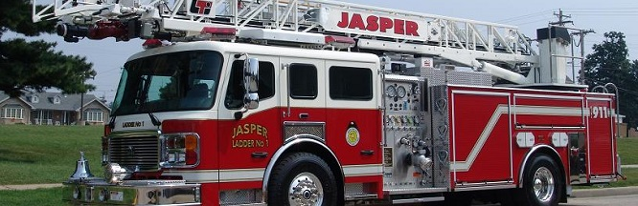

***JASPER FIRE DEPARTMENT***

### VOLUNTEER FIREFIGHTER

**(PROBATIONARY)**

The Jasper Volunteer Fire Department is a city department that relies upon dedicated individuals who are willing to use their time and talents for the benefit of the community. The essential duties and responsibilities include performing duties relating to basic firefighting and emergency rescue. Must be able to respond to fire alarms and other emergency calls 24 hours a day. Drives and operates firefighting vehicles and equipment as required. Serves weekend station duty when scheduled. Attends meetings and trainings as directed by the Fire Chief and Assistant Fire Chiefs.

**Applicant must:**

(1) Have received a state accredited high school diploma or equivalent;

(2) Be at least eighteen (18) years of age;

(3) Must reside within the Corporate City Limits of Jasper, or in any area extending up to two (2) miles from the municipal boundary;

(4) Must be able to pass a fitness for duty physical examination;

(5) Must pass a pre-employment drug screen test; and

(6) Must hold a valid Indiana Driver's License.

#### If you are interested in an exciting challenge and service to your community, APPLICATIONS may be picked up from:

**City of Jasper Fire Chief – 6th Street Fire Station, 309 E. 6th St.**

**OR**

**Personnel Office, Jasper City Hall**

**EOE #F2024**

An Equal Opportunity Employer