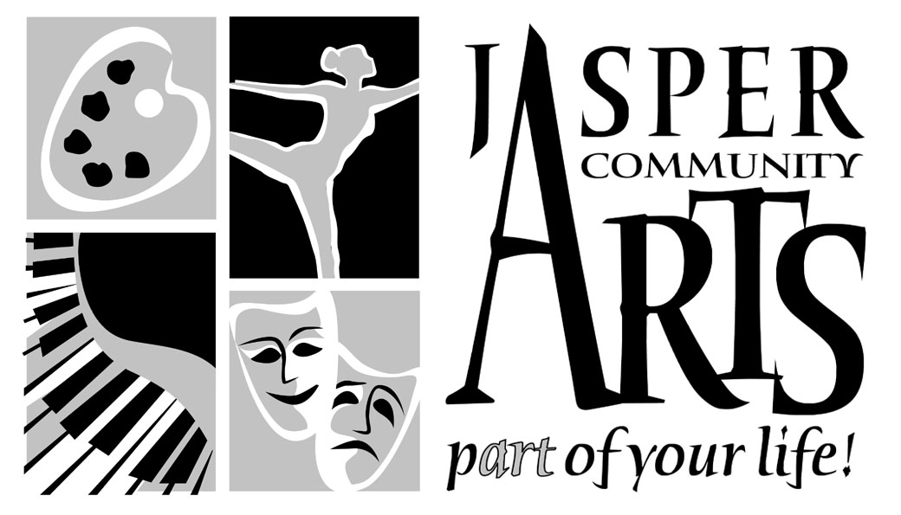

Jasper Community Arts

951 College Avenue

Phone: 812-482-3070

Fax: 812-634-6997

[www.jasperarts.org](http://www.jasperarts.org)

E-mail: kmiracle@jasperindiana.gov

# MEDIA RELEASE

**FOR IMMEDIATE RELEASE**

**DATE: January 12, 2016**

**CONTACT PERSON: KIT MIRACLE, DIRECTOR**

**SUBJECT: GUITARISTS FRANK VIGNOLA AND VINNY RANIOLO PLAY BACKSTAGE AT JASPER ARTS CENTER**

Gypsy swing guitarists Frank Vignola and Vinny Raniolo will perform Friday, January 22, 2016, at 7:30 p.m. at the Jasper Arts Center. This will round out the Backstage series for our 40th anniversary.

With more than 1,000 engagements in the five years they’ve been performing as a duo, acoustic guitarists Frank Vignola and Vinny Raniolo have become one of the most popular and sought-after duos on the international music scene. Their dynamic genre-spanning music has brought them to 14 countries on three continents, performing in some of the world’s most illustrious venues, including the Sydney Opera House in Australia, New York’s Lincoln Center, and Teatro Olimpico in Vicenza, Italy.

Drawing on more than 500 years of classic songs, Vignola and Raniolo create unique, sometimes intense and often quite beautiful arrangements of these familiar and beloved songs. Although both guitarists have been deeply influenced by many great jazz guitarists, they are not merely a jazz guitar duo. There is a sense of spontaneity, imagination and virtuosity that are hallmarks of jazz and are fully present in their performances.

A typical performance will take the audience on a breathtaking whirlwind tour of musical history. Bach, Mozart and Beethoven will be freely mixed with Ellington and Waller, blended with Gershwin and Carmichael, peppered with Bob Marley, Led Zeppelin, Sting and Lennon/McCartney and spiced with Rodrigo and Lecuona. As brilliant musicians, Frank and Vinny never allow their virtuosity to overshadow the purpose of their music, which is to entertain their audiences.

Frank describes the essence of their music in clear and straightforward terms, “There is nothing more satisfying to my ears than two guitars performing a beautiful song. As a duo, we seek out beautiful songs and melodies spanning hundreds of years and try to create a uniquely fresh version.” He goes on to say, “We like to have people leave our shows feeling better than when they arrived. Night after night, all over the world, we see how happy people are after a show. This is very important to us. We love to entertain people. Obviously, we entertain with the music, but making people laugh a bit or having a few comedic lines is very satisfying.”

Frank first met Vinny in a jam session in New York in 2006. After playing in various combinations of groups, they locked into their current duo format around 2009. Each musician still has an individual musical career and both have played with some of the biggest names in the industry: Tommy Emmanuel, Bucky Pizzarelli, Jane Monheit, Leon Redbone, Wynton Marsalis, Queen Latifa, The Boston Pops and many more.

Education is also an important element for both musicians. Frank has produced seven educational courses and written 18 guitar instruction books as well as has over 100 students enrolled in online courses throughout the world. Both products of public performing high schools, they conduct school master classes, workshops and hold jam session-style clincs at many universities, grade schools and music camps.

In addition to their strenuous touring schedule, they still find time to perform at some of the major music festivals such as, Vail Jazz Festival, Vancouver Island Music Festival, Ards Guitar Fest in Ireland as well as others throughout the world.

Patrons wishing to learn more about this musical duo can check out their websites at: [www.frankvignola.com](http://www.frankvignola.com) or [www.vinnyraniolo.com](http://www.vinnyraniolo.com).

Jasper Community Arts is a department of the City of Jasper. Additional support is provided by Friends of the Arts, Inc., the Indiana Arts Commission, Arts Midwest, and the National Endowment for the Arts. It is also a Kennedy Center Partner in Education and provides arts education programming to local schools.

#####