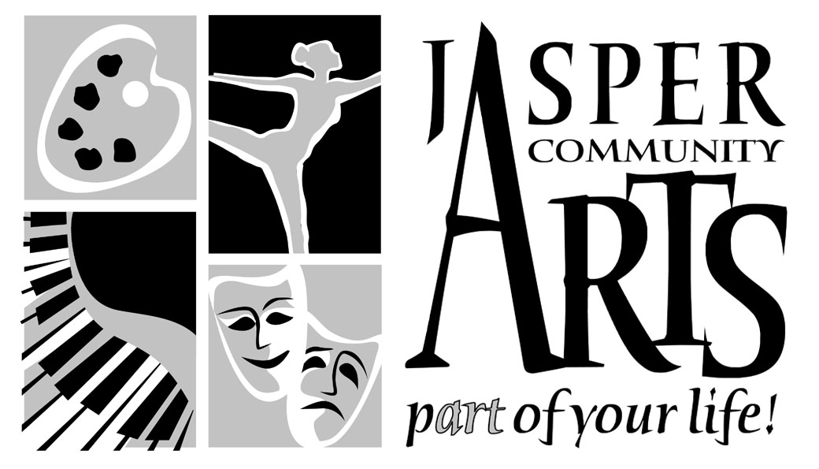

Jasper Community Arts

951 College Avenue

Phone: 812-482-3070

Fax: 812-634-6997

[www.jasperarts.org](http://www.jasperarts.org)

E-mail: kmiracle@jasperindiana.gov

# MEDIA RELEASE

**FOR IMMEDIATE RELEASE**

**DATE: March 22, 2017**

**CONTACT PERSON: KIT MIRACLE, DIRECTOR**

**SUBJECT: SIMON AND GARFUNKEL REVISITED AT JASPER ARTS CENTER**

In 1981, more than 500,000 music fans gathered in Central Park to witness the now legendary reunion of folk duo Simon & Garfunkel. Award-winning recording artists, Lee Lessack and Johnny Rodgers recreate that magical night. With dulcet vocals harmonizing over lilting guitar, you’ll hear all the beloved poetic masterpieces that made Simon & Garfunkel famous: *Mrs. Robins, Homeward Bound, Scarborough Fair, Bridge Over Troubled Waters, The Sound of Silence*, and many more. The concert will be held at the Jasper Arts Center on Sunday, April 2, 2017 at 7:30 p.m. This event will wrap up the 2016-2017 performing arts season.

The original concert in 1981 was created as a fundraiser for the then-run down Central Park. Proceeds went toward the redevelopment and maintenance of the park. The concert and resulting album marked the start of a short-lived reunion for Paul Simon and Art Garfunkel. The concept had been proposed by Parks Commissioner Gordon Davis and promoter Ron Delsener. HBO recorded and carried the concert which has been seen on PBS many times since. Unfortunately, ongoing personal tensions between the duo led them to decide against a permanent reunion, despite the success of the concert and subsequent world tour.

The Live in Central Park concert is not one of impressions or impersonation; but a re-visit with the music that made these nights magical. The two main performers are Lee Lessack and Johnny Rodgers backed by a musical trio.

Lee Lessack’s graceful Lyric baritone vocals and sophisticated, yet endearing persona have made him a shining star on the international concert scene. *Billboard Magazine* calls his singing *caberet romanticism of a high order.* Touring extensively in the United States and Europe to sold-out performances and releasing eight albums, Lessack has proven himself both as a performer and recording artist.

A Philadelphia native, Lessack sharpened his acting skills at the American Academy of Dramatic Arts and then chose to pursue the concert route over Broadway. He now resides in Los Angeles where, in 1996 he founded LML Music ([www.LMLmusic.com](http://www.LMLmusic.com)) which has a catalog of over 100 of the country’s top live recording artists and performers.

Johnny Rodgers is an internationally-celebrated singer-songwriter, pianist, music ambassador, Broadway star, and recording artist who is described by Stephen Holden of *The New York Times* as an entertainer *who has show business in his bones* with *fused elements of Billy Joel, Peter Allen and Johnny Mercer.*

Johnny Rodgers recently returned to Chicago, the place he says started it all. Since beginning his career there fifteen years ago, Johnny has traveled the country and the world making music with such greats as Billy Joel, Judy Collins, Liza Minnelli and more. No matter where he roams, Rodgers dazzles audiences with his Americana mélange of original songs and classic favorites. He tours with his band as music ambassadors for the State Department to places such as the Middle East, North Africa, Southeast Asia, the Pacific Islands and Russia. This year, he will be touring back in Europe. He has performed at most of the major New York music venues – Carnegie Hall, Lincoln Center, Birdland, and other premier clubs. People who want to learn more can visit his website at [www.johnnyrodgers.com](http://www.johnnyrodgers.com) .

People who wish to experience this very special musical treat should call the Jasper Arts Center right away at (812) 482-3070. Tickets are still available but they’re going fast! Prices are $35 for adults, $33 for seniors and $30 for students and children. Group rates available.

Jasper Community Arts is a department of the City of Jasper. Additional support is provided by Friends of the Arts, Inc., the Indiana Arts Commission, and the National Endowment for the Arts with special thanks to the Vanderburgh County Community Foundation.

#####