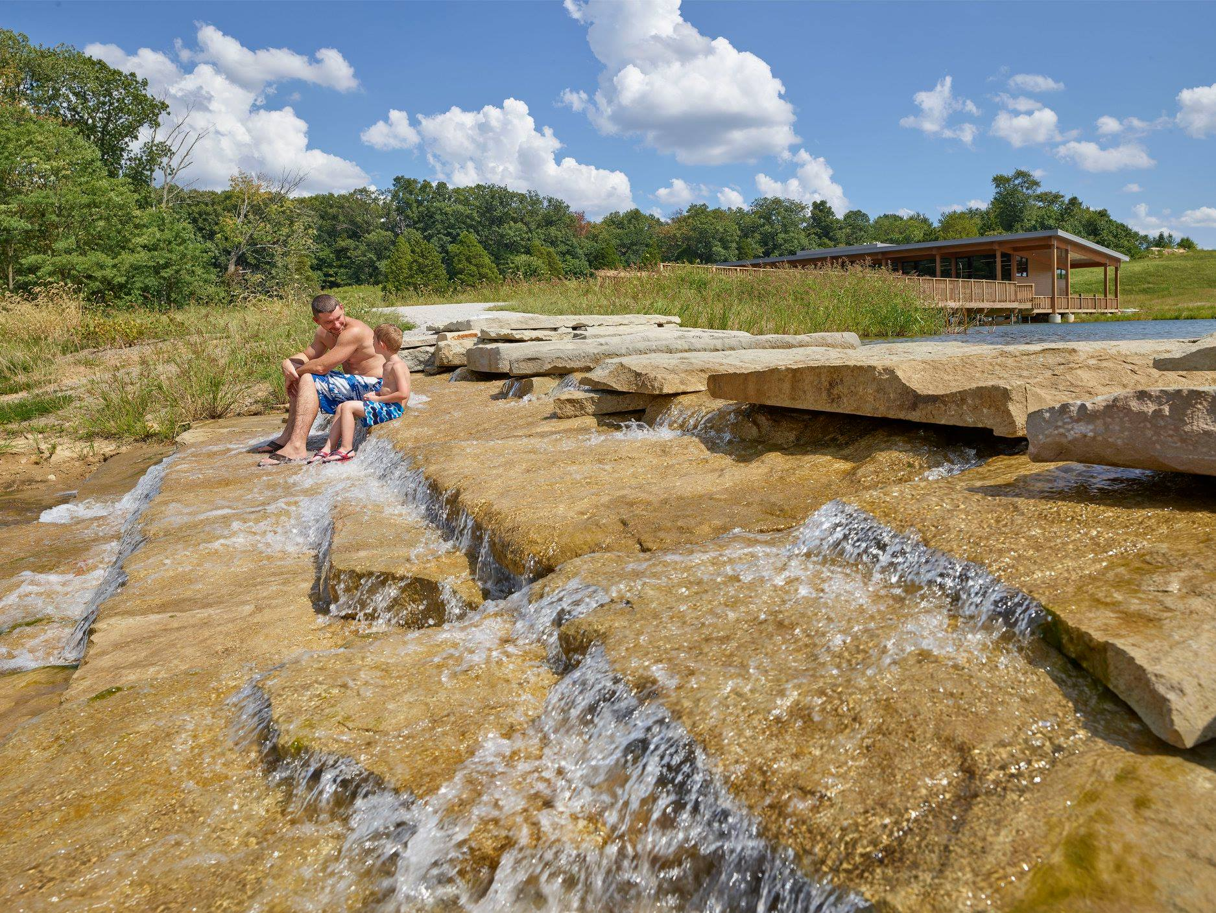

|  |
| --- |
| Director of Park and Recreation  City of Jasper, Indiana |
| The City of Jasper, Indiana, is a progressive, growing community of over 15,000 people known as a community of action and quality of place. Jasper, a regional hub in southwestern Indiana, has a park system that encompasses 15 community parks, a municipal pool, the Parklands, Beaver Lake, Jasper Youth Sports Complex, Buffalo Trace Golf Course, the Older American Center, walking paths, the Spirit of Jasper Train and a professional staff engaged in recreational programming and maintaining and improving the parks and recreational facilities. Working within the policies, budgets, and directives established by the Mayor and Park Board, the Director is responsible for all operations of the Park and Recreation department.  ESSENTIAL JOB FUNCTIONS:  This position is responsible for all park operations, ensuring compliance with federal/state/local environmental, safety and health regulations, and department policies and procedures.  Plans, organizes and administers dynamic park development. Plans for safety and meets current and future park needs of the Jasper community.  Identifies and analyzes community trends and needs for park and recreation programs, facilities and land, and recommend strategies for meeting those trends and needs.  Maintains required fiscal reports and complete records of department property, services, personnel, office operations and various programs; preparing and administering an extensive departmental budget and balancing department accounts.  Leader and role model with a positive presence; demonstrates initiative; and able to communicate effectively with other government agencies and officials, employees and members of the public.  EDUCATION and/or EXPERIENCE:  Bachelor’s degree in Park-related disciplines such as park management, recreation, and/or related field; or comparable post-graduate degree or certification. Additional two or more years related work experience preferred. |
|  |

Submit resume by November 13, 2020 with cover letter of interest, qualifications, and references to:

Personnel Director

EOE# 357

C/O: City of Jasper

P.O. Box 29

Jasper, Indiana 47547-0029

or email to: [hra@jasperindiana.gov](mailto:hra@jasperindiana.gov)

An Equal Opportunity Employer

You can find additional information about the City of Jasper and our Park and Recreation Department at www.jasperindiana.gov.