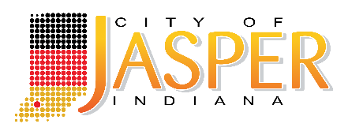
UTILITIES BUSINESS OFFICE

BUSINESS OFFICE ASSISTANT

The Jasper Municipal Utilities seeks an outgoing, confident individual who truly enjoys working with the public as a full-time Business Office Assistant. The Business Office Assistant will have both administrative and strategic responsibilities, helping to plan and administer important functions of the department. The selected individual must be a detail oriented, self-starter with strong office skills who will work with a wide variety of responsibilities including, but not limited to, assisting with all operations of the Utility Business Office. Reviews invoices, obtains Utility Managers’ approval and process accounts payable. Responds to vendor inquiries and maintains vendor file information. Calculates weekly payroll timecards for utility employees. Processes accounts receivable and inputs various journal entries. Maintains materials and supplies inventory. This individual will also attend Utility Service Board and various sub-committee meetings and records and publishes minutes of meetings. Assists with Customer Service and Billing Departments as a back-up by having a working knowledge of all related functions. The ideal candidate will be well organized and able to work with little direct supervision. Proficient in Microsoft Office and comfortable with learning new technical systems as needed. Related experience and/or training is preferred. Selected individual must be capable of maintaining a high level of confidentiality.

Submit resume with cover letter of interest, qualifications, and references to:

PERSONNEL DIRECTOR
EOE #399
c/o City of Jasper
P.O. Box 29
Jasper, IN 47547-0029
or email to: hra@jasperindiana.gov

An Equal Opportunity Employer

