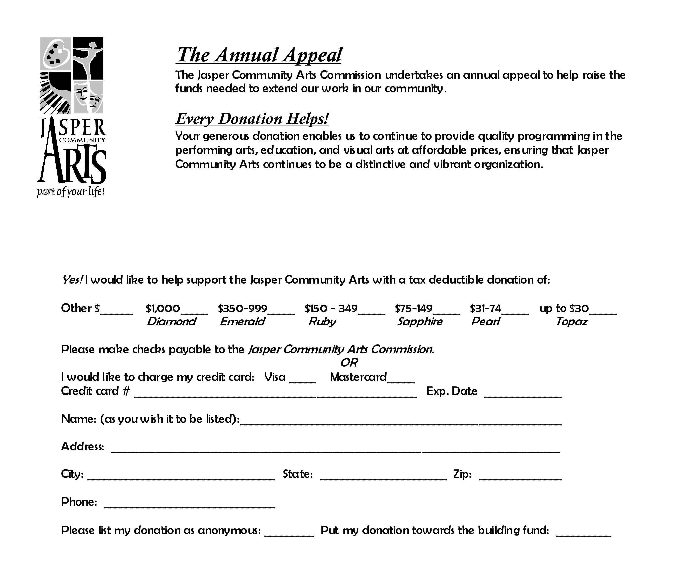

Please mail your donation to:

Jasper Community Arts Commission
951 College Avenue
Jasper IN 47546

