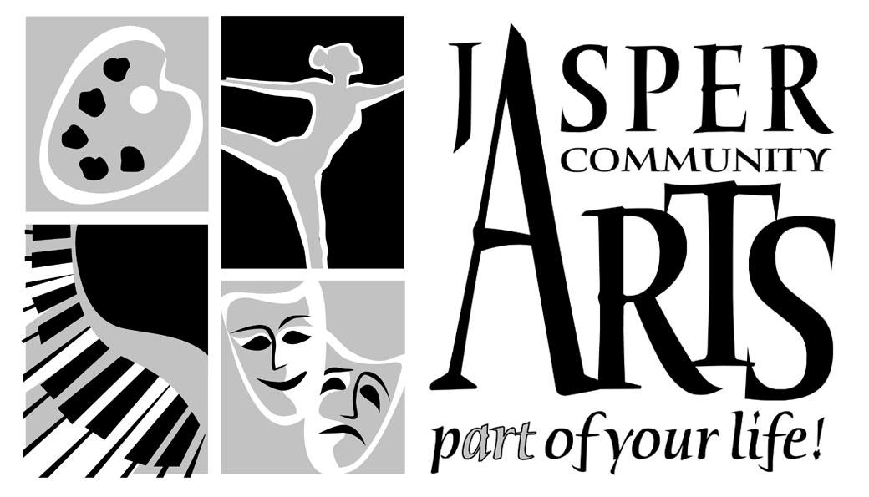
951 College Avenue
Jasper IN 47546

Phone: 812-482-3070
Fax: 812-634-6997

www.jasperarts.org
E-mail: visualarts@jasperindiana.gov

FOR IMMEDIATE RELEASE
CONTACT PERSON: EMILY PEAK, VISUAL ARTS COORDINATOR

DATE: April 7, 2017
SUBJECT: Deadline for Submissions to 24th Annual Juried Art Show at Krempp
Gallery
DEADLINE DATE: June 30, 2017
The Krempp Gallery at the Jasper Arts Center encourages artists to submit applications for the 24th Annual Juried Art Show, September 2017. Only artists who are current or former residents of Indiana, Illinois, Kentucky, Michigan or Ohio can apply.

Applications are now available on our website: www.jasperarts.org. To apply, send by email or snail-mail digital images of the appropriate dimensions, along with the application. The application must be postmarked by June 30, 2017.

The juror, Betsy Stirratt has been exhibiting her paintings, books, objects and installations since 1983. Her work has been shown at the National Museum of Women in the Arts in Washington, The American Craft Museum, White Columns, and Art in General in New York, and in galleries in Chicago, Houston, Los Angeles and elsewhere. She is the recipient of several grants and awards, including a Visual Artist Fellowship from the National Endowment for the Arts and awards from the Indiana Arts Commission and the American Craft Council. Her work is represented by Red Arrow Gallery in Nashville, TN.

She is currently the Director of the Grunwald Gallery of Art at Indiana University in Bloomington. As Director, she has curated numerous exhibitions including Feminine Persuasion, Personal: Selections from the Robert J. Shiffler Collection, Human Nature and The Miniature. She has edited several books and catalogs, including The Miniature, Grunwald Gallery, Indiana University (2015), Human Nature, School of Fine Arts Gallery, Indiana University (2007), Les Vérités du Sexe, Editions Marval, Paris, France (French, German editions, 2003) and Feminine Persuasion: Contemporary Women’s Sexuality, Indiana University Press, Bloomington, IN (2003).
$2,000 in prize monies will be awarded in the categories of BEST OF SHOW, AWARD OF EXCELLENCE, HIGH HONOR AWARD, and five HONORABLE MENTIONS.

The Krempp Gallery, located in the Jasper Arts Center adjacent to the VUJC campus, is open to the public Monday through Friday from 8:30 a.m. to 5 p.m., until 7 p.m. on Thursdays, and Sunday from noon to 3:00 p.m. School groups, clubs, and students are welcome. Admission is free.

For more information, please call the Jasper Arts Center at 812-482-3070. The Krempp Gallery is managed by Jasper Community Arts, a department of the City of Jasper. JCA is supported by the Friends of the Arts, Inc., the Indiana Arts Commission, through its regional partner the Vanderburgh Community Foundation, and the National Endowment for the Arts.

###

