951 College Avenue
Jasper, IN 47546-9382
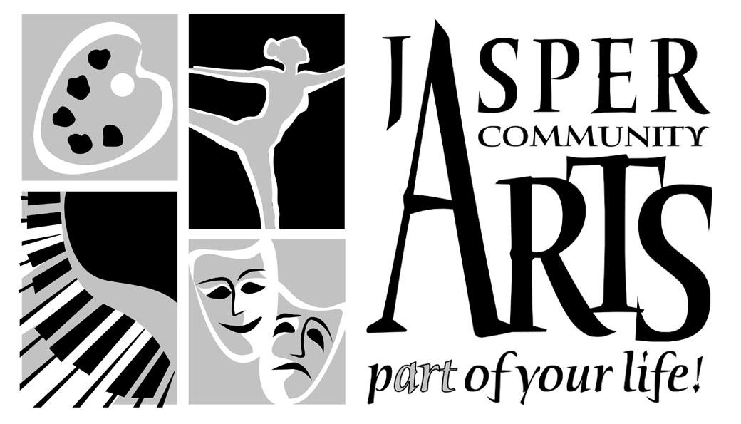
Phone (812) 482-3070
FAX (812) 634-6997
Email: visualarts@jasperindiana.gov

MEDIA RELEASE
FOR IMMEDIATE RELEASE
February 9, 2017
CONTACT PERSON: Emily Peak, VISUAL ARTS COORDINATOR

SUBJECT: YOUTH ART MONTH AT KREMPP GALLERY

The artwork of students from throughout Dubois County will once again be featured at the Krempp Gallery during Youth Art Month. March is YOUTH ART MONTH in Indiana and nationally. The Art Education Association of Indiana and the National Education Association have chosen March as a time to recognize and celebrate the creativity and artistic talents of our children. Art organizations and art educators are asked to come together to help local communities to highlight art education this month. In this spirit, the Jasper Community Arts will be hosting the Annual “Youth Art” Exhibit from March 1 – 30, 2017, in the Krempp Gallery at the Jasper Arts Center.

This year’s exhibit will be showcasing artwork by area high school and elementary school students. Participating in the display are: Southridge High School, Jasper High School, Forest Park High School and Northeast Dubois High School. The second half of March will feature the local elementary schools which are: Celestine Elementary, Dubois Elementary, Pine Ridge Elementary, Ferdinand Elementary, Holy Trinity Elementary, and 10th Street Elementary.

The High School Exhibit will be on display March 1-13, with a public reception Sunday, March 5th, 12-2 pm.

The Elementary School Exhibit will be on display March 15-30, with a public reception Sunday, March 19th, 12-2 pm.

There will be no ‘First Thursday’ event this month due to two Sunday Youth Art Month Receptions.

The Krempp Gallery is open Monday through Friday from 8:30 am until 5 pm, Thursdays 8:30 am to 7 pm, and Sundays noon to 3 pm. The Jasper Community Arts Commission is a department of the City of Jasper, and receives funding from the Friends of the Arts, The Indiana Arts Commission and the National Endowment for the Arts.

A DEPARTMENT OF THE CITY OF JASPER

