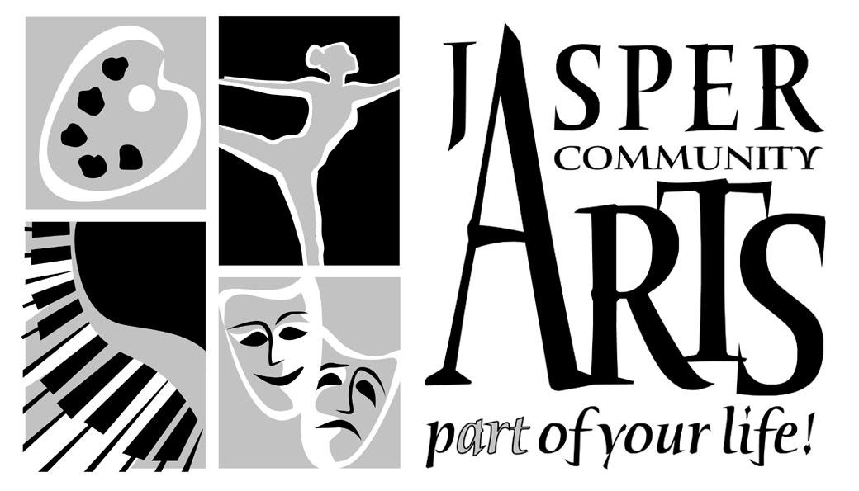
951 College Avenue
Jasper IN 47546

Phone: 812-482-3070
Fax: 812-634-6997
www.jasperarts.org
E-mail: visualarts@jasperindiana.gov

FOR IMMEDIATE RELEASE

DATE: January 12, 2016
CONTACT PERSON: EMILY COLUCCI, VISUAL ARTS COORDINATOR
SUBJECT: QUICK DRAW AND PLEIN AIR EVENT IN DUBOIS COUNTY
DATES: MAY 13 AND 14, 2016

To kick off the year, Jasper Community Arts is preparing for its second Plein Air and Quick Draw event. The painting event will take place in Dubois County on Friday, May 13 and Saturday, May 14, 2016. Enjoy a weekend of painting the charms of southern Indiana- hills, rivers, fields, quaint villages and more!

Plein Air, simply described, is painting outdoors rather than in a studio. The term comes from the French ‘en plein air’, meaning ‘in the open air’. The Impressionists were particularly interested in the influence of changing light and the effects of light on color when outdoors. Monet is a popular example of a plein air painter.

The Quick Draw Event is a plein air competition, exhibit, and sale. This competition is a timed event that starts promptly at 4:00 pm and lasts for 90 minutes. The artists must have their canvas stamped prior to the start of the event. Artists only have a short time to create and frame one plein air piece within a designated boundary near the Schaeffer Barn. Artists may use any medium to create their art piece. Artwork must be created only from the surrounding area and the artists may not use models or references to work from.

This particular kind of event is extremely popular and has taken place nationwide in numerous cities and towns. Call the Jasper Arts Center to register today. Plein Air Event is $15, Quick Draw Event is $15, and both are $25. Sign up before March 31st and enjoy both events for only $20! Early registration is encouraged; however artists may register the day of the event. Free gifts, prizes, entertainment and more!

For a schedule of events, more information and how to register, visit our website at www.jasperarts.org or please call us at 812-482-3070. The Jasper Arts Center is managed by the Jasper Community Arts Commission, a department of the City of Jasper. The JCAC is supported by the Friends of the Arts, Inc., the Indiana Arts Commission through its regional partner the Vanderburg Community Foundation, and the National Endowment for the Arts.

A DEPARTMENT OF THE CITY OF JASPER
###

